**Code:**

#20CS007 Khush Bhalodiya

class Stack:

def __init__(self):

self.stack = []

def check_empty(self):

return self.stack == []

def push(self, data):

self.stack.append(data)

print(f"{data} is added to the stack")

def pop(self):

if(self.check_empty()):

return "Stack is Empty"

return self.stack.pop()

def display(self):

print("Stack is ",end="")

for i in self.stack:

print(i,end=" ")

stack = Stack()

print("Pushing operation in stack")

stack.push("1")

stack.push("2")

stack.push("3")

stack.push("4")

stack.display()

print("\nPopping operation in stack")

stack.pop()

stack.display()

**Output:**

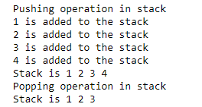

**GitHub Link:**

https://github.com/Khush1351/Python-Practicals.git